Rover Assembly Instructions
When I took the pictures, I did not have the exact hardware, and I did not have washers.
This is the easiest way I’ve found to set up the rover. Follow these steps in order:

Step 1
Use:
- 2 × M3x10mm (or M3x12mm) screws
- 2 × M3 washers
- 2 × M3 hex nuts
Attach the first 3D-printed bracket using this hardware.
Then repeat the same process with the same amount of hardware to attach the second bracket.
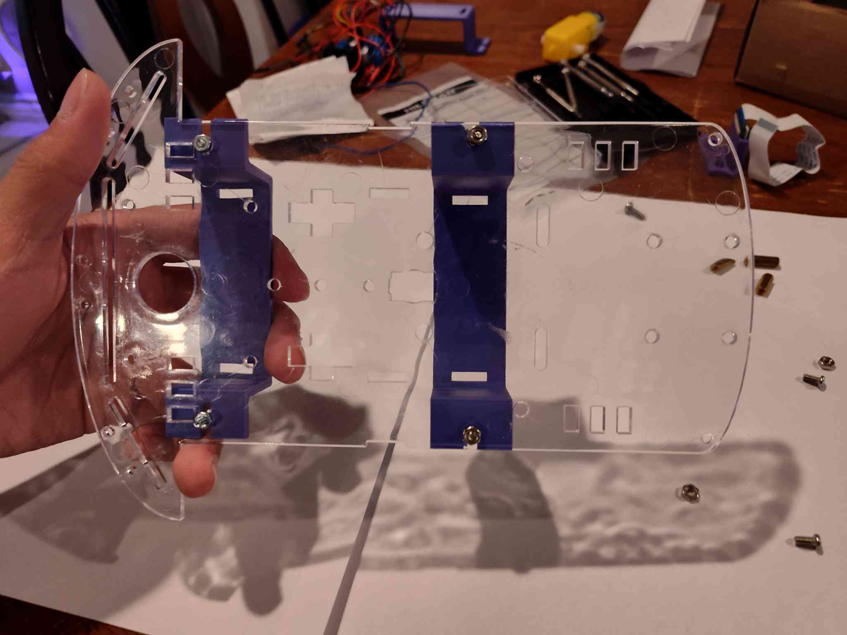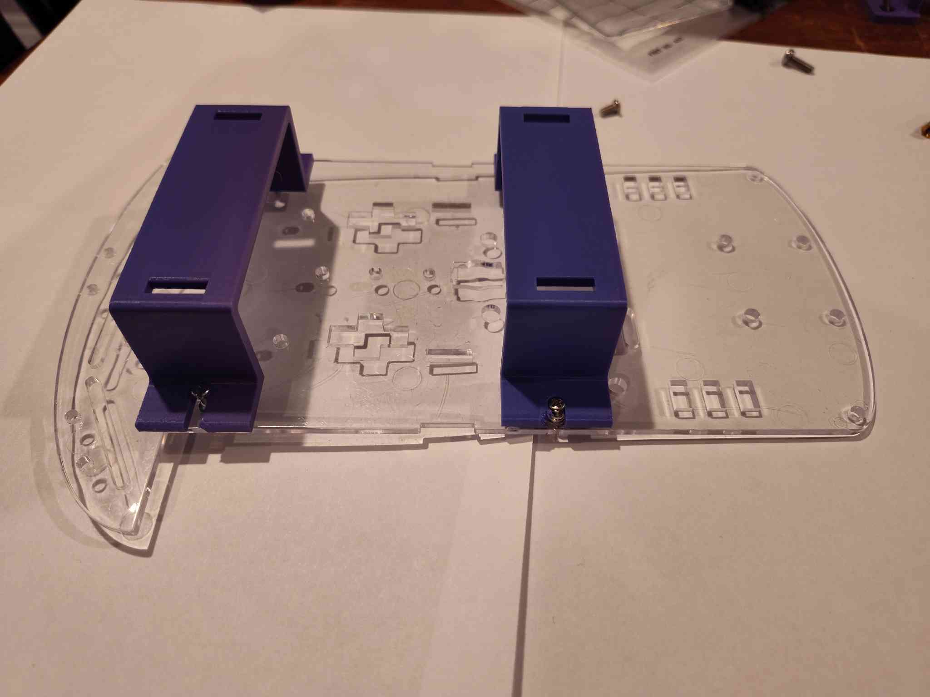

Step 2
This is the hardest part.
You will need two clear plastic inserts. Look closely at the picture, as it can be difficult to tell where they go.
Insert the two clear pieces together as a pair. Make sure the wider part is at the top so it does not fall through.
When inserting the long screws:
- Insert them from the inside out.
- This will leave space to screw on the hex nut.
- The hex nut should be on the outside of the rover.
- The screws should go in from the inside of the rover.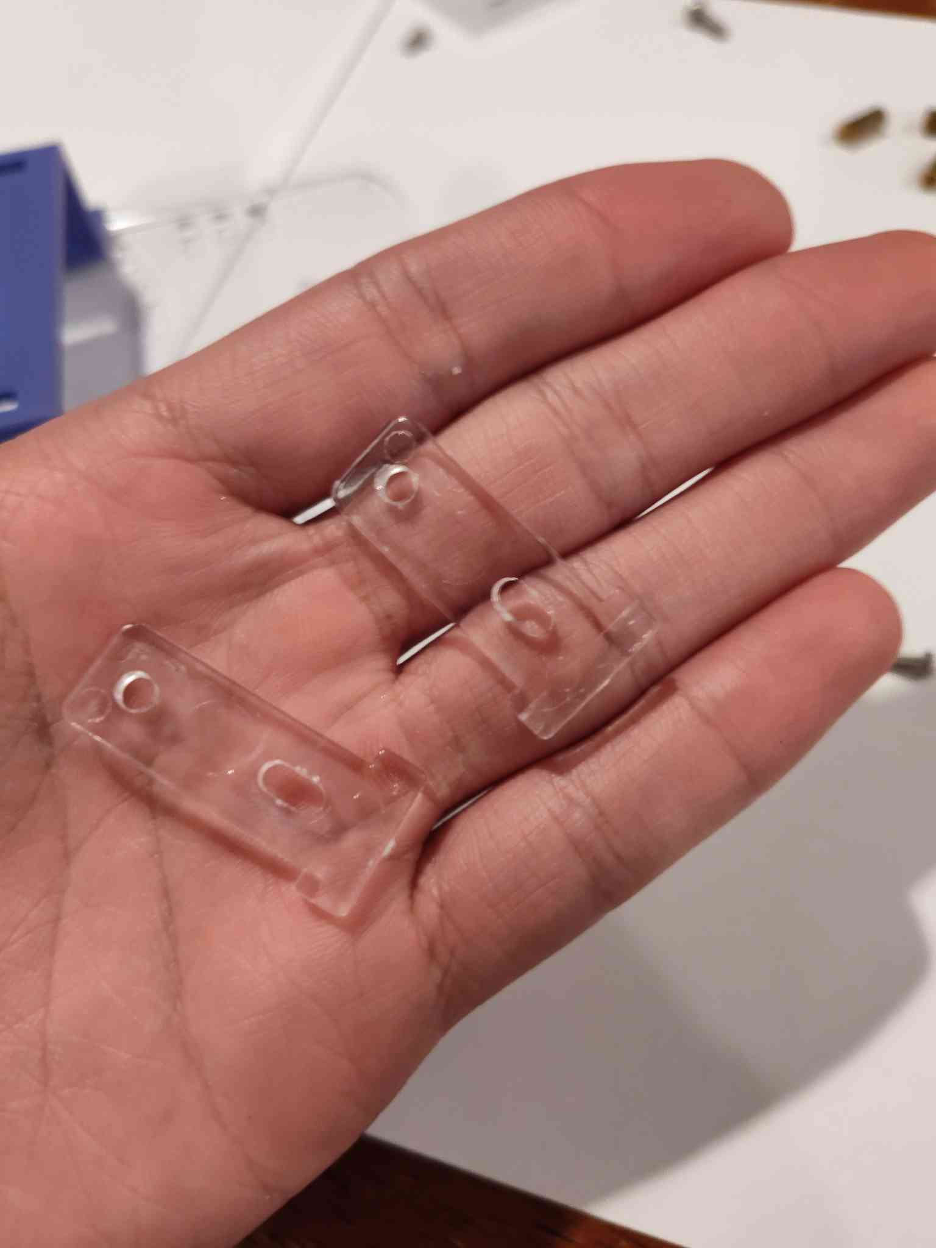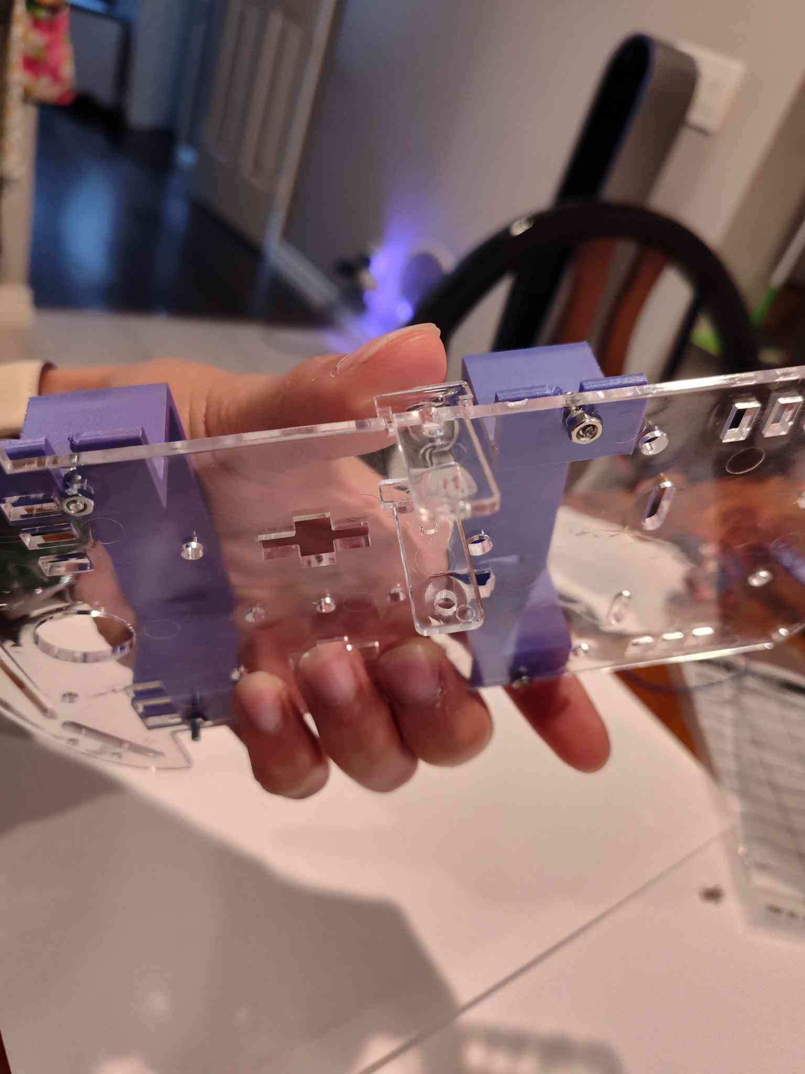 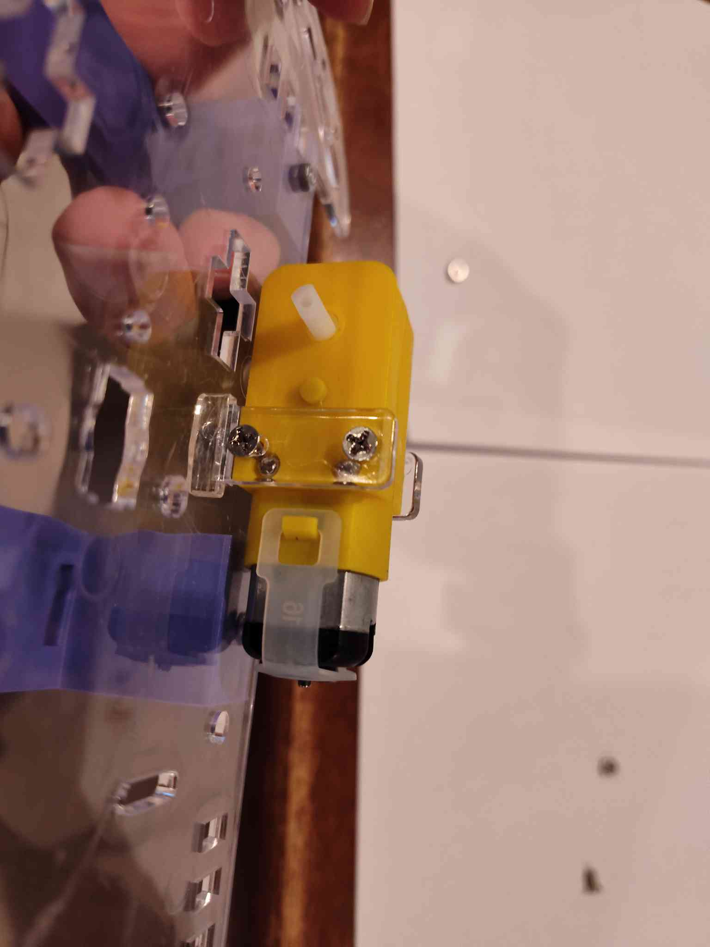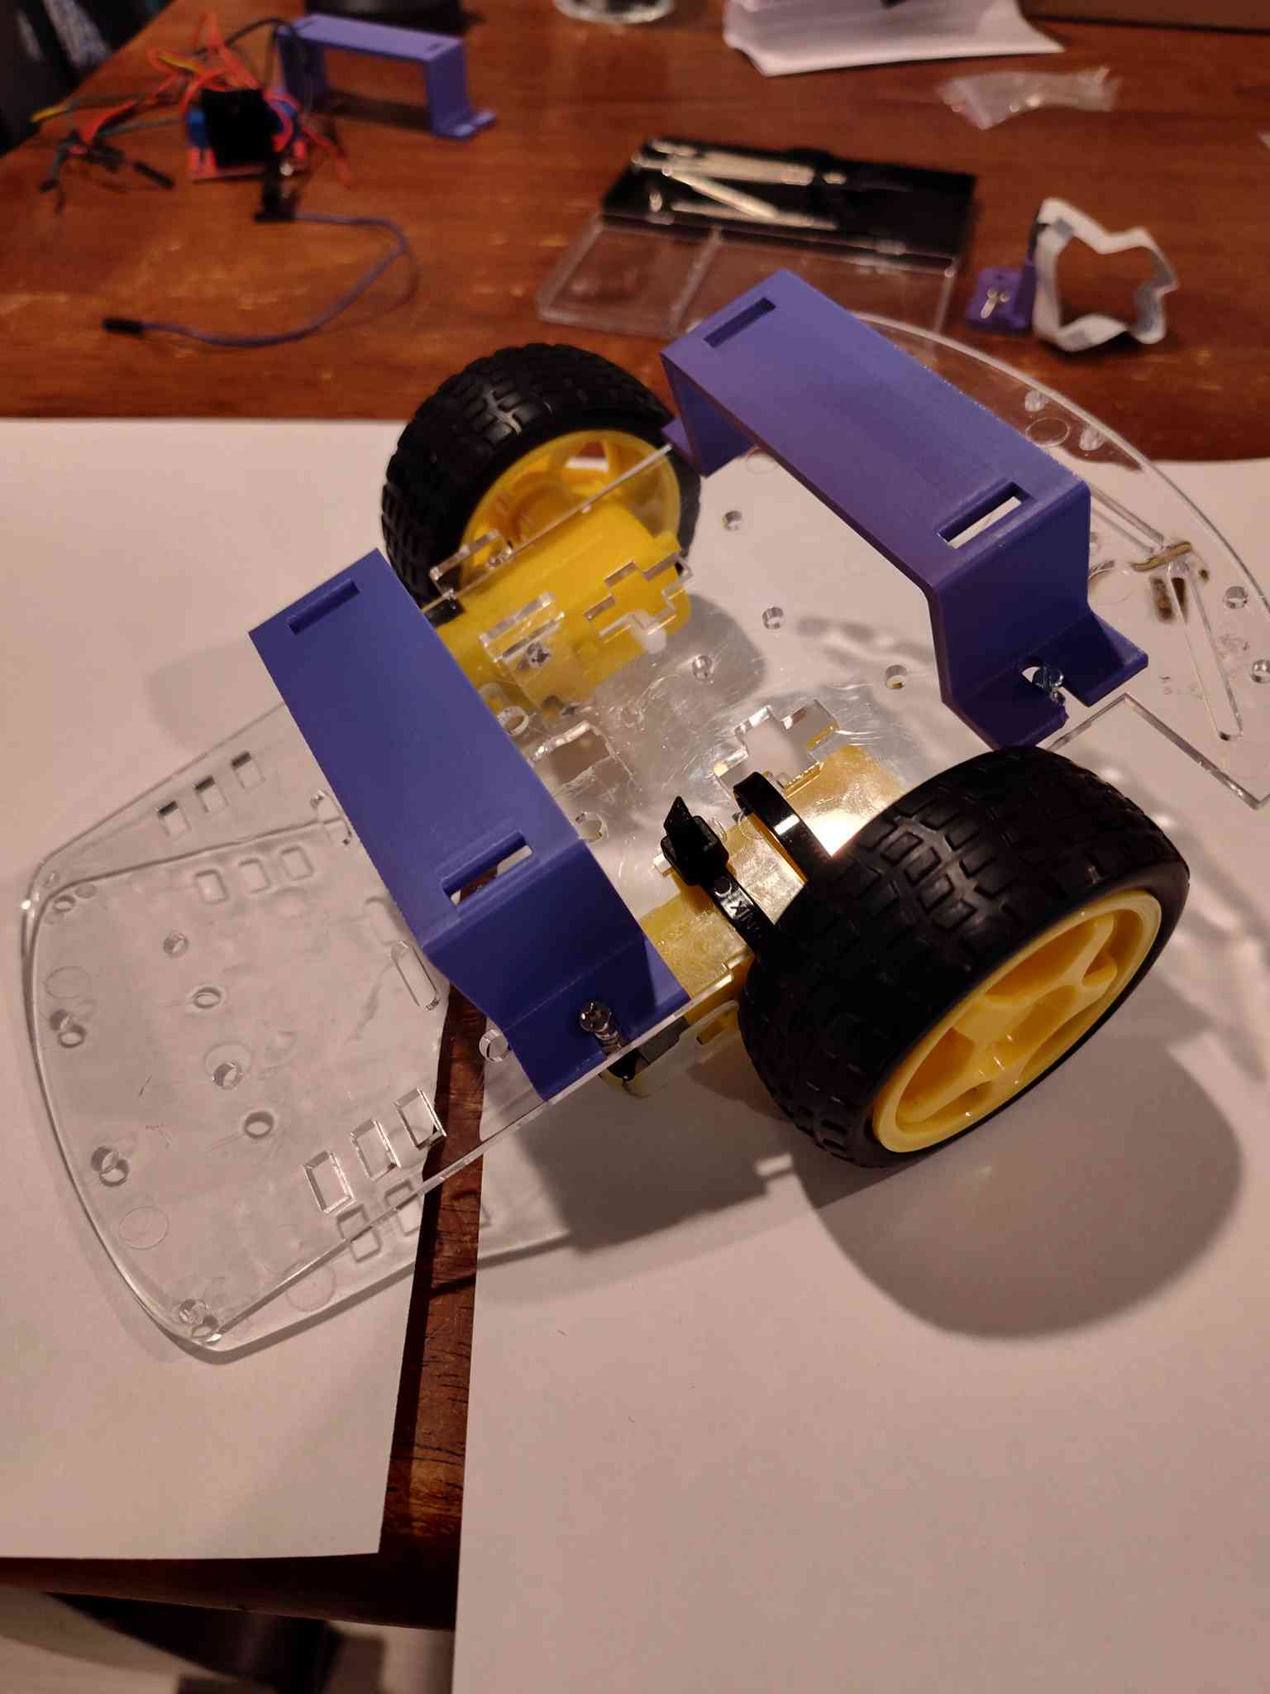

Step 3
We will now attach the caster wheel at the very front.
- Insert the four screws through the caster wheel and attach the standoffs.
- Tighten the standoffs so they are securely fastened to the caster wheel.
Next:
- Line up the standoffs with the holes on the front of the rover.
- Screw in only the front two screws first.
Now attach the camera mount:
- Position the mount so the open part of the slot faces forward.
- Screw the mount into the back two standoffs.
Finally, attach the front bumper using:
- 2 × M3x8mm (or M3x10mm) screws
- 2 × M3 washers
- 2 × M3 hex nuts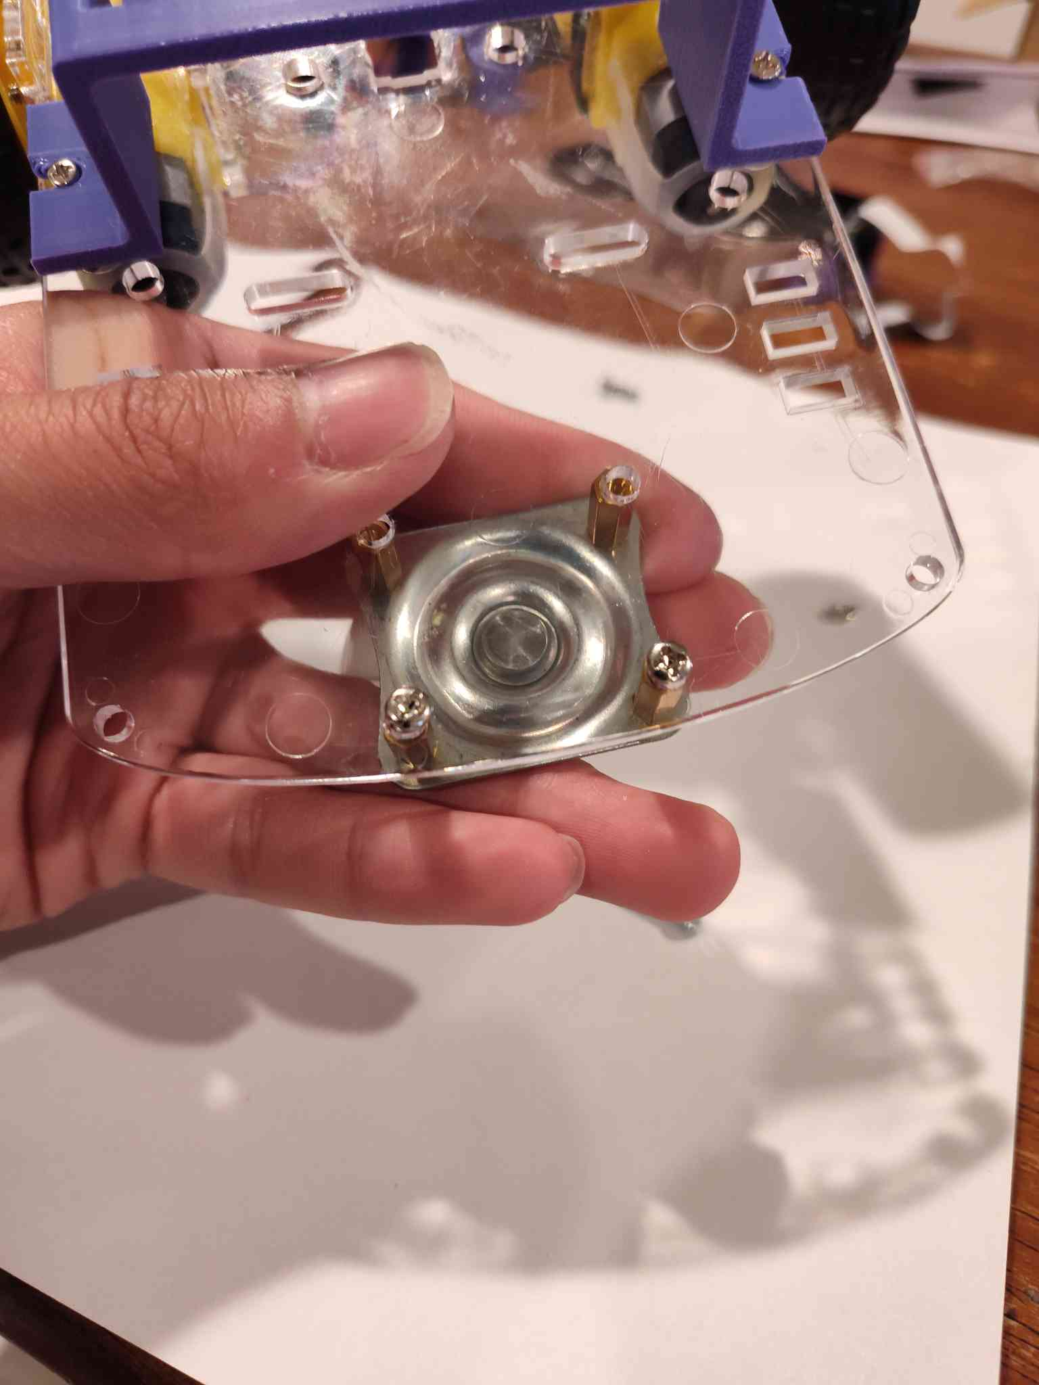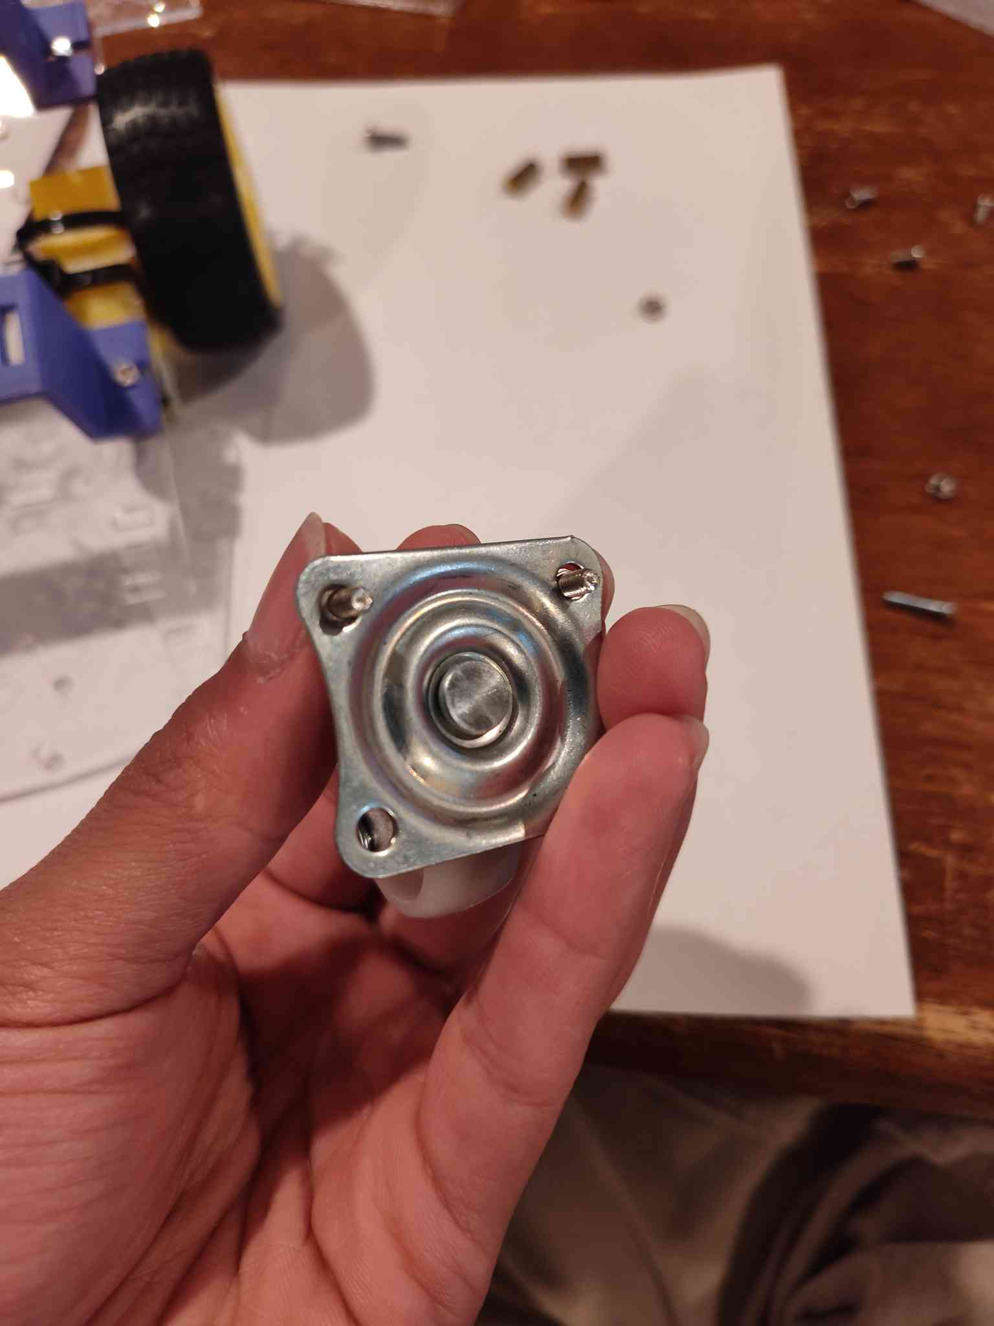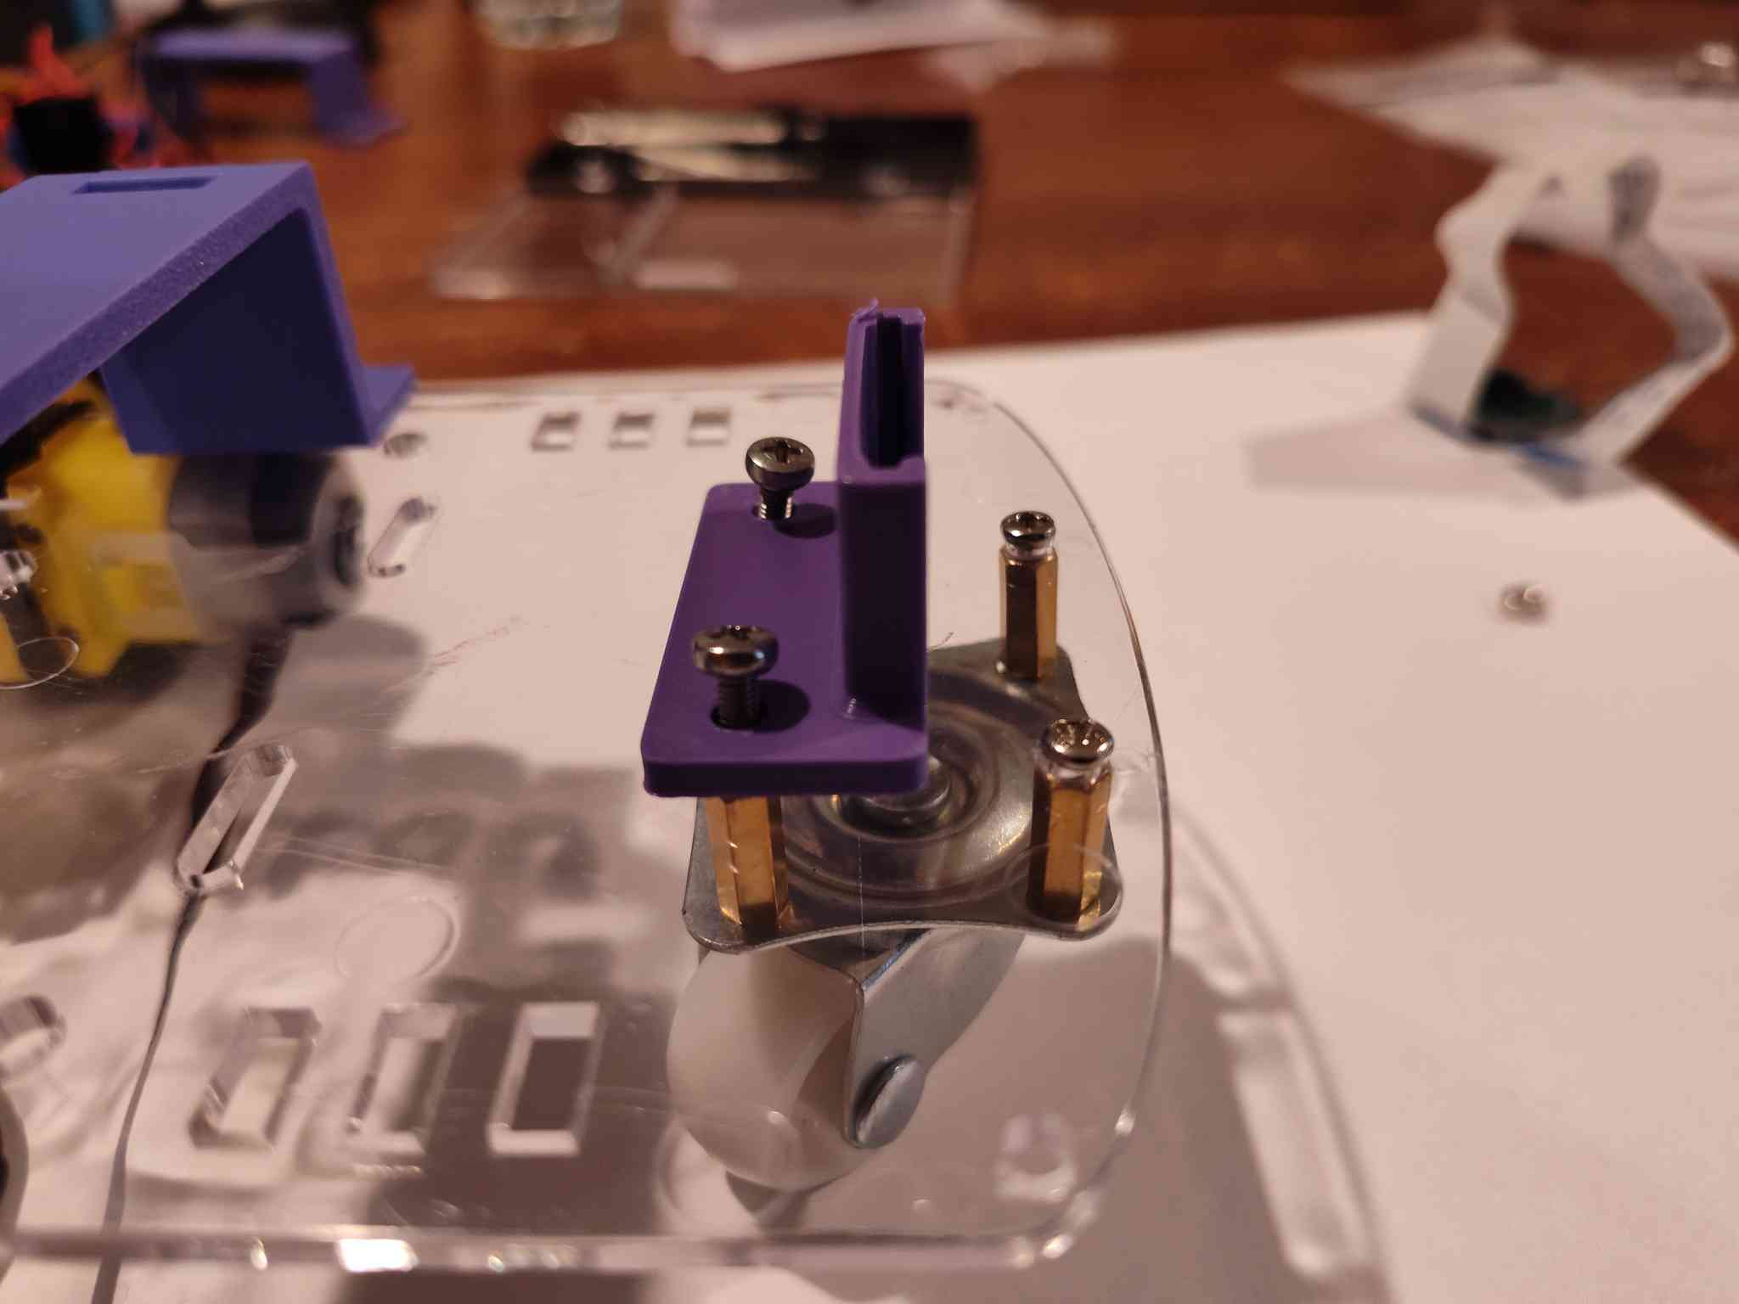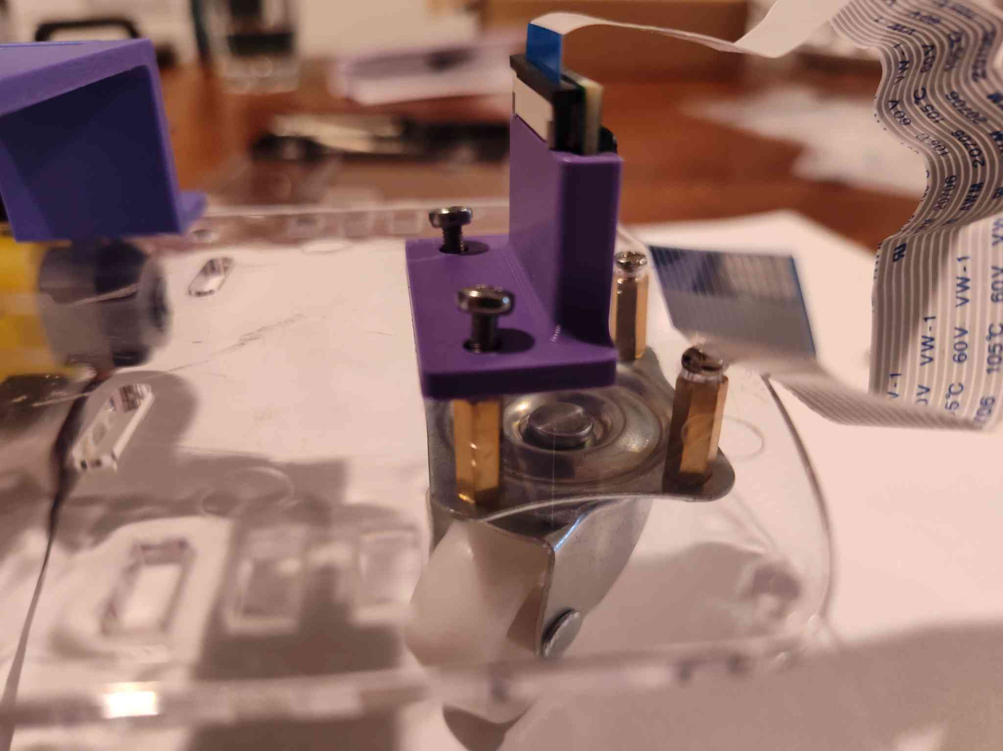

Main Frame Complete
The main frame is now complete. Next, we will attach the electrical components.

Electrical Component Installation
Camera
- Slide the camera into the mount with the ribbon cable facing upward.
Power Bank
- Slide the power bank through the brackets.
- It will be a snug fit.
- The power bank will rest on top of the clear plastic gearbox motor holders.
Raspberry Pi 4
- Use a cable tie (zip tie) to secure the Raspberry Pi 4 to the front bracket.
Motor Driver
- Use a cable tie (zip tie) to attach the motor driver to the back bracket.
9V Battery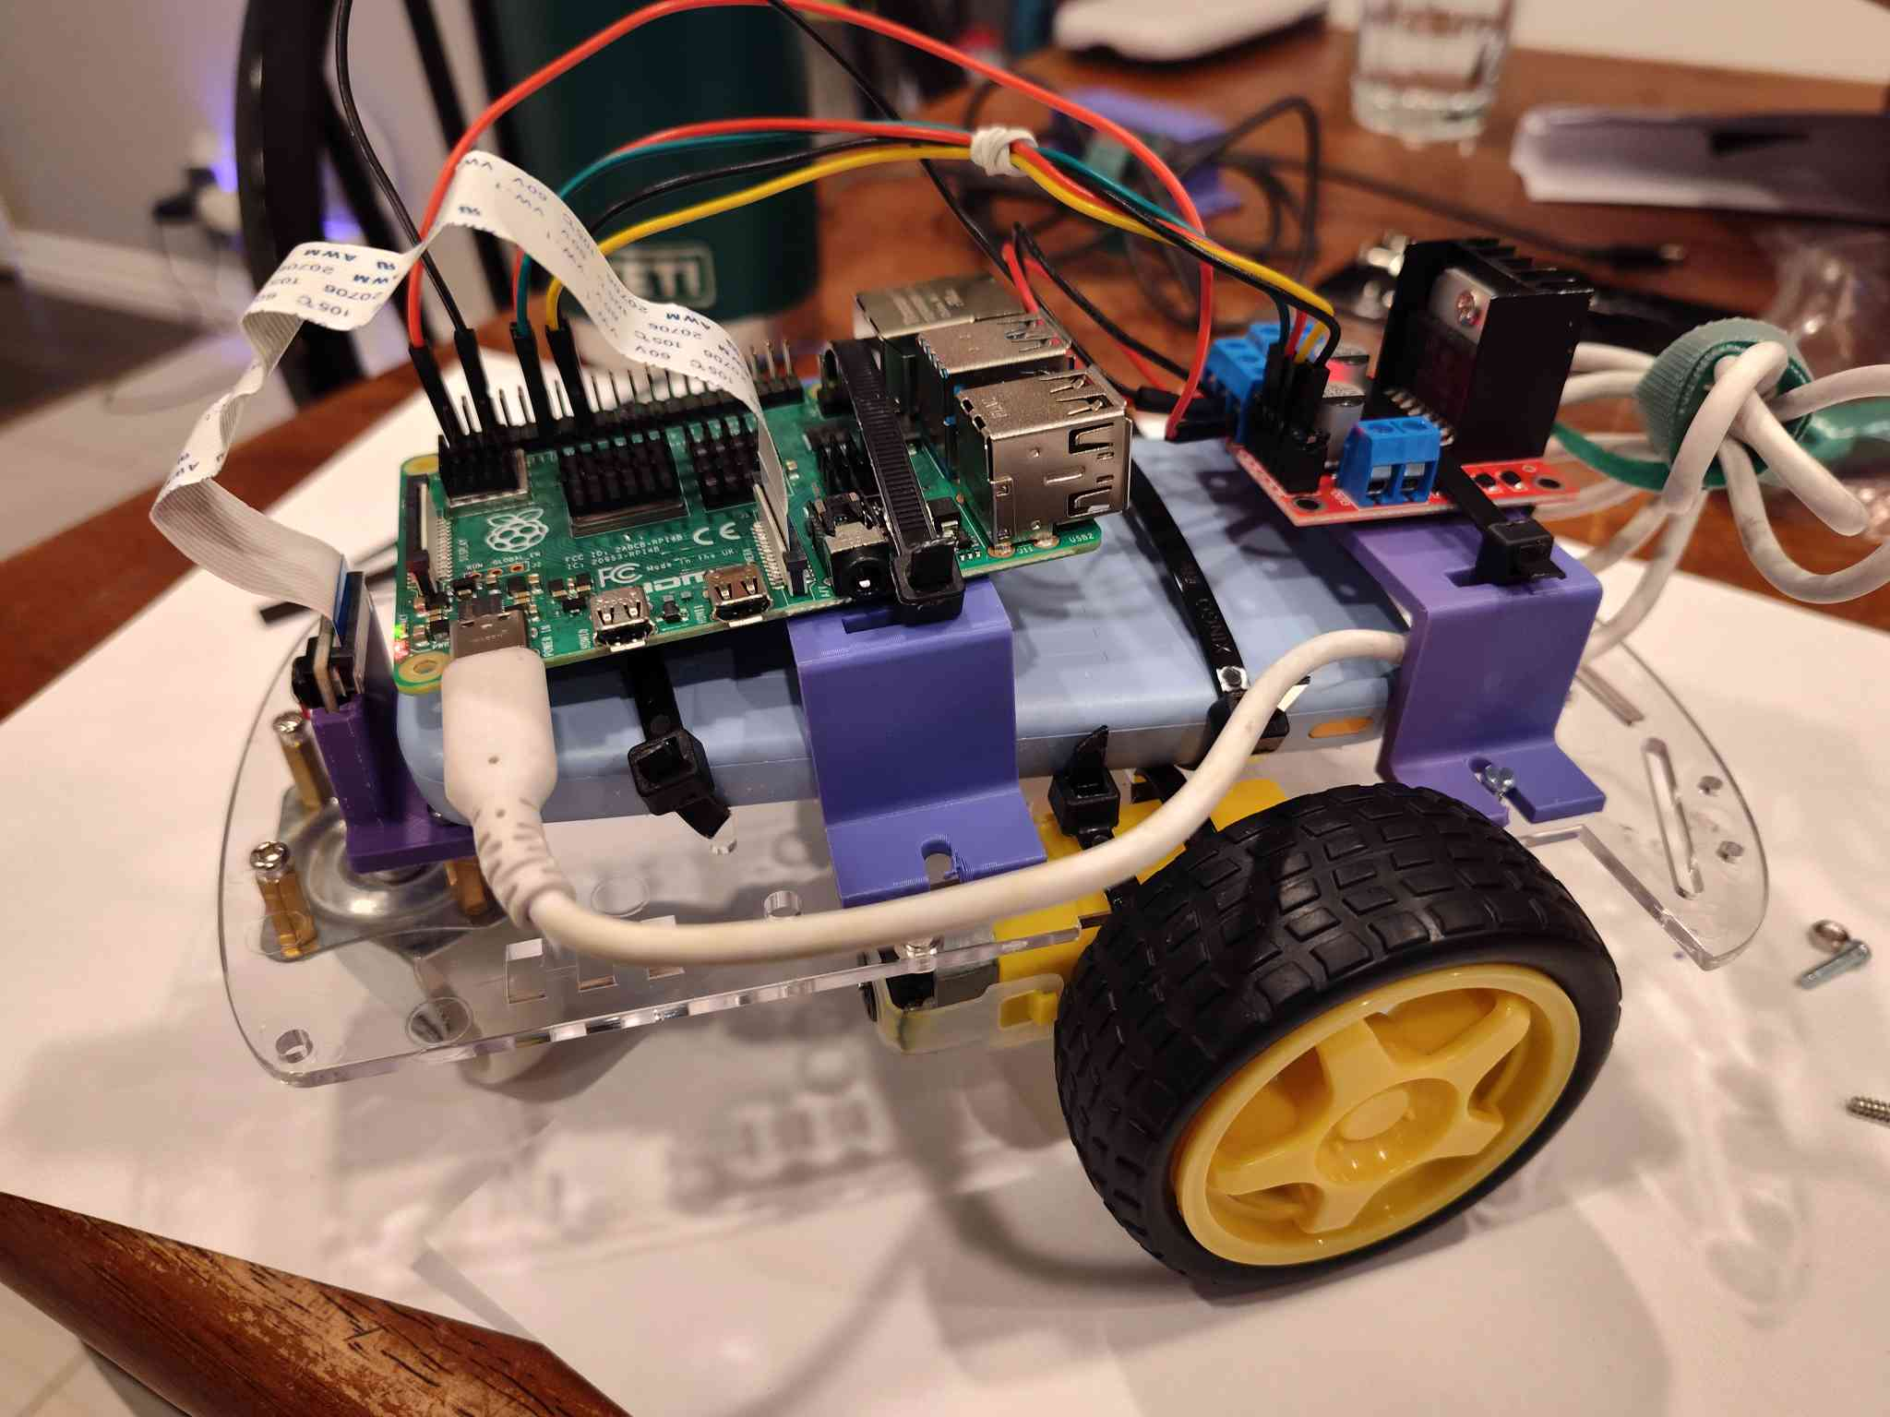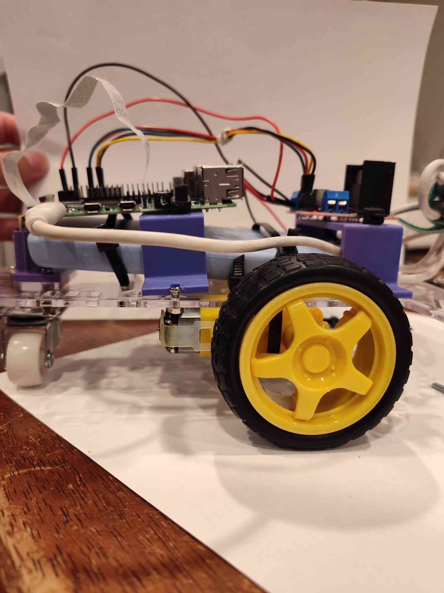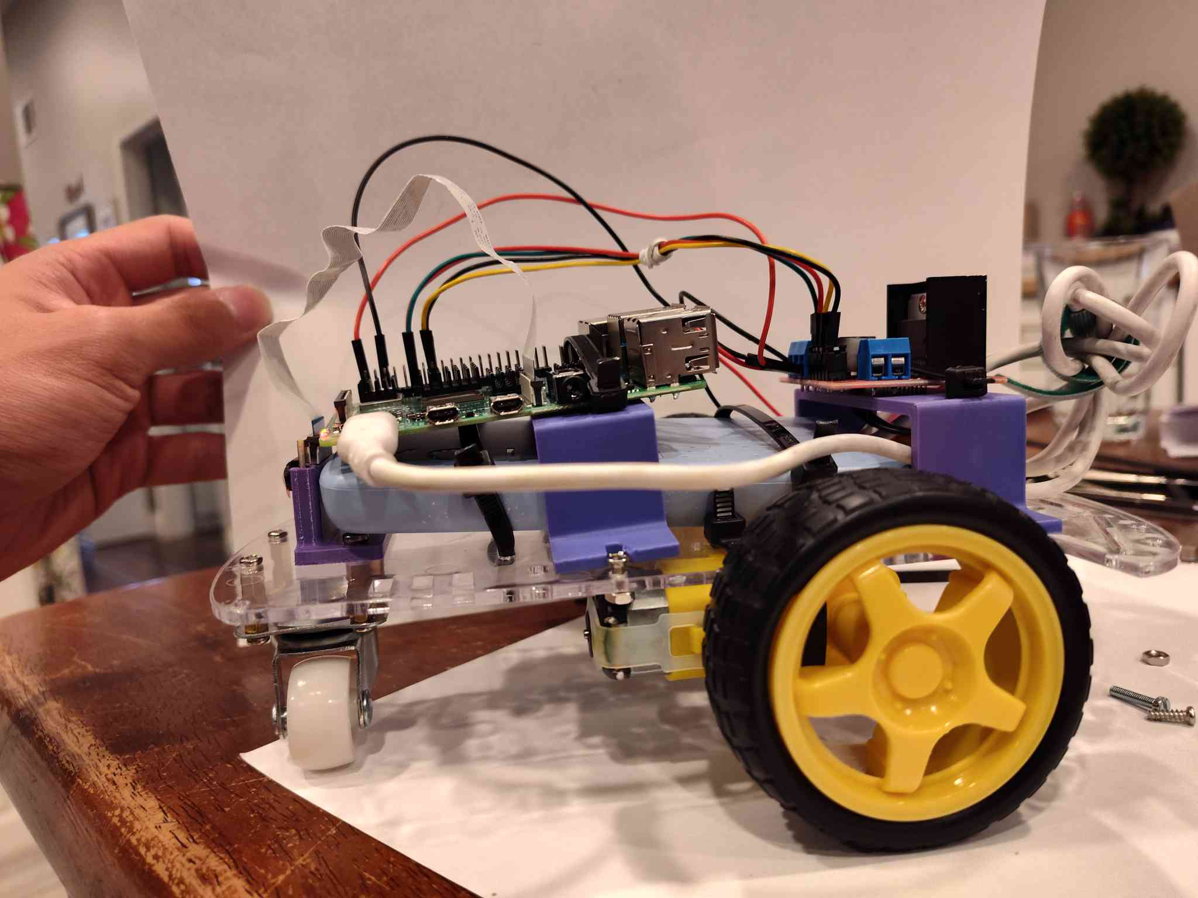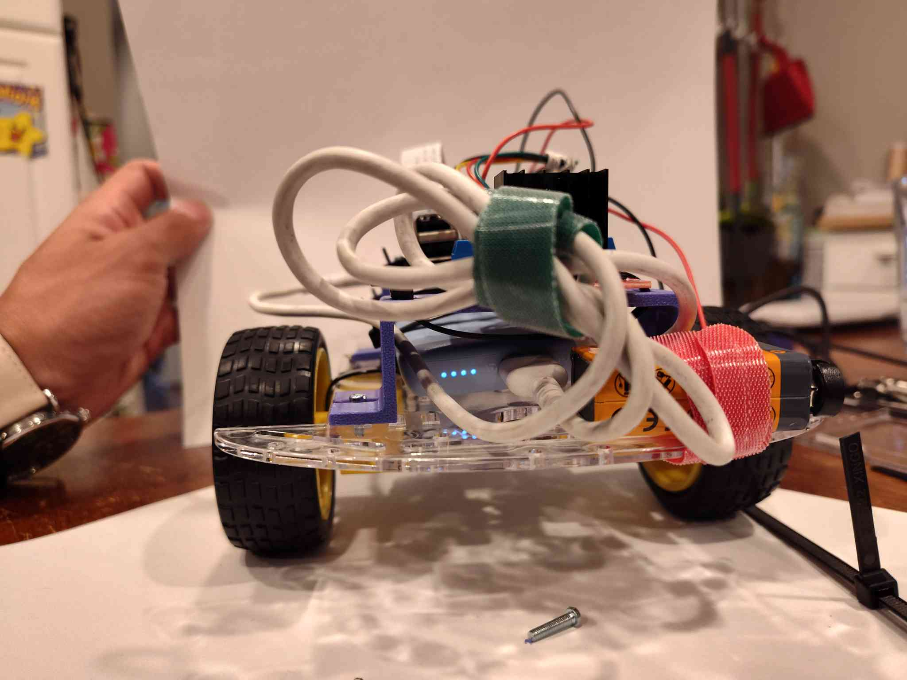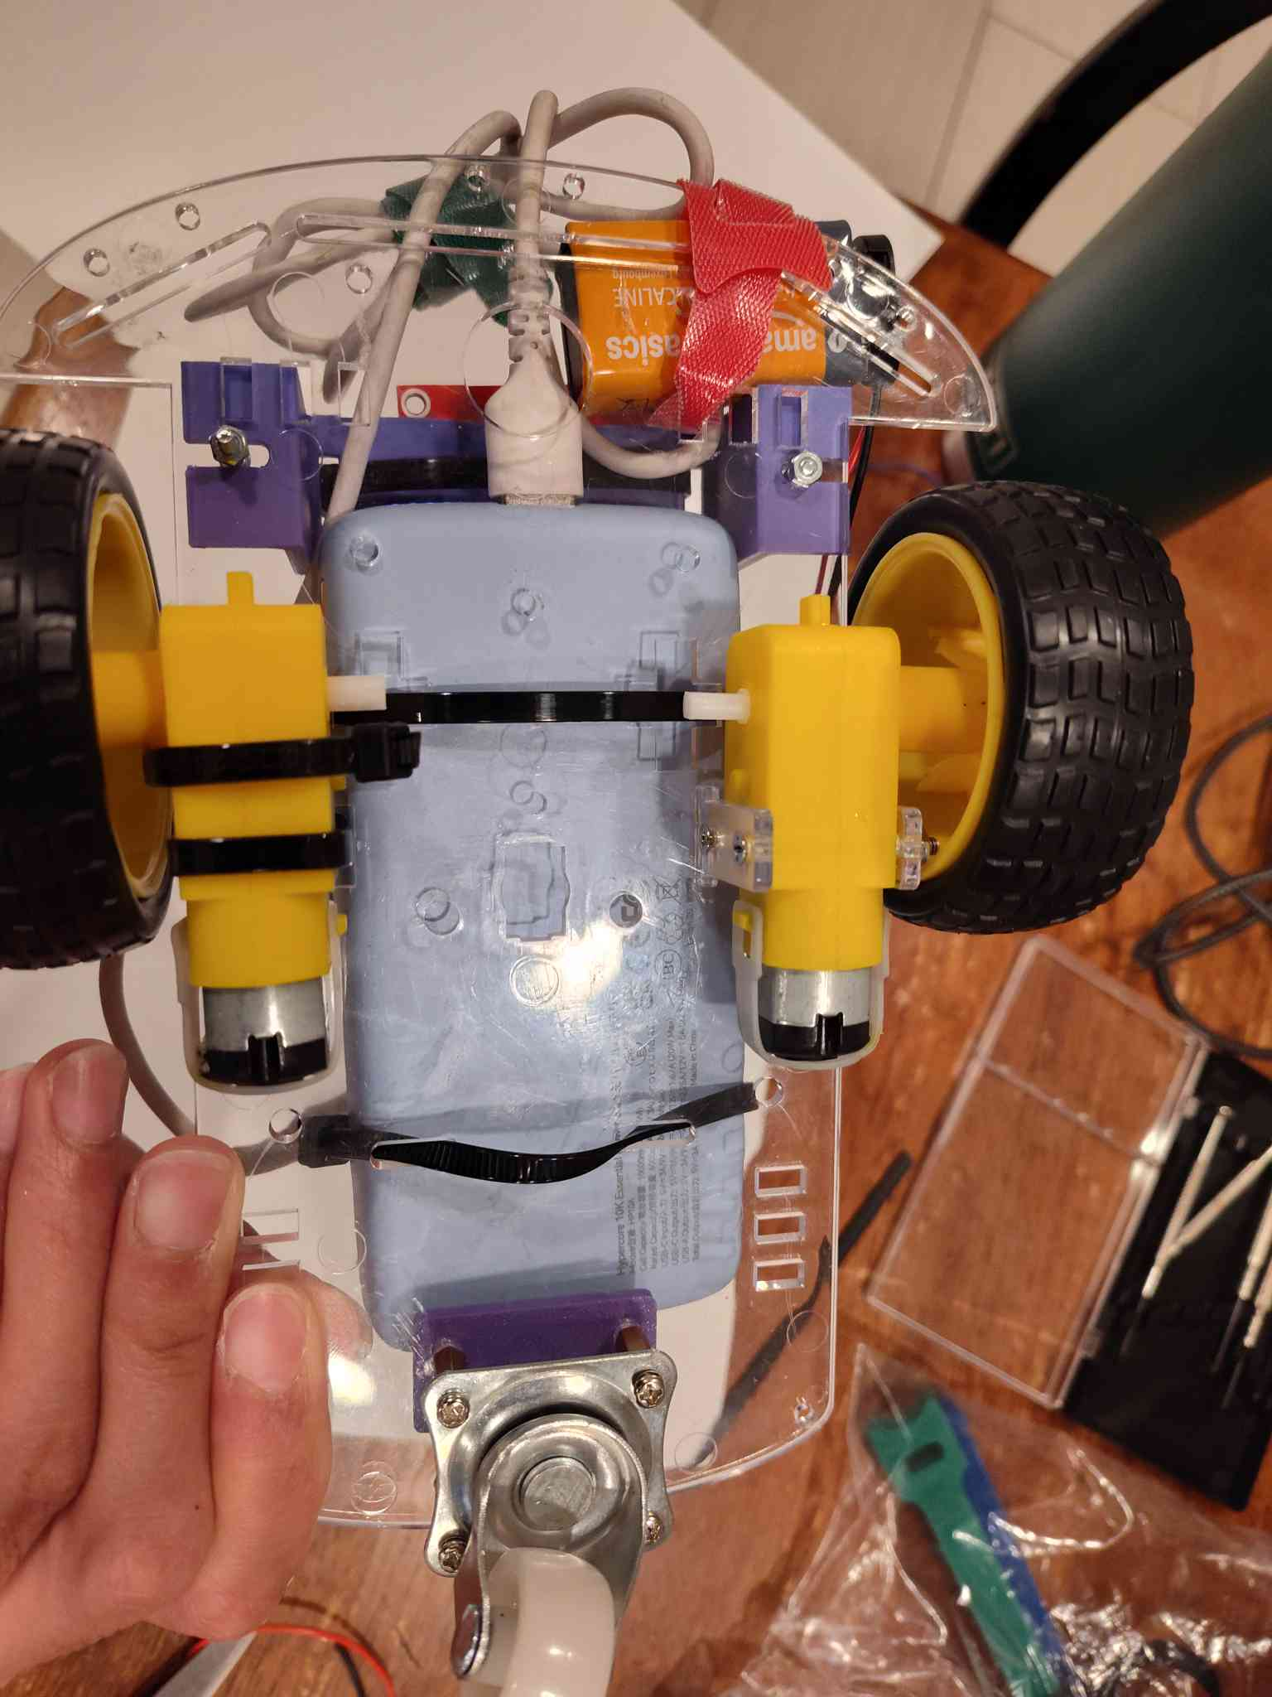
- Use a cable tie (zip tie) to secure the 9V battery to the back of the rover.

The rover assembly is now complete and ready for wiring and programming

